MATURI VENKATA SUBBA RAO ENGINEERING COLLEGE
Department of Information Technology
(Affiliated to Osmania University, Hyderabad. Recognized by AICTE)
Nadergul, Saroornagar Mandal, Hyderabad-501510

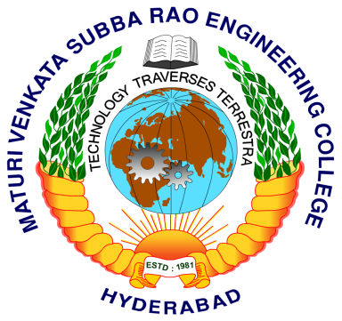

CERTIFICATE

This is to certify that the project entitled, “LEAF DISEASE DETECTION USING MATLAB AND MULTISVM” is being submitted by N.SHALINI REDDY [Roll No. 2451-16-737-002], A.JYOTHI [Roll No. 2451-16-737-008], and K.VINAY KUMAR [Roll No. 2451-16-737-009] in partial fulfillment of the academic requirements for the award of the degree of Bachelor of Engineering in Information Technology to the Osmania University, is a record of bona fide work carried out by him under my guidance and supervision. The results obtained in the project have not been submitted to any other industry or institute for the award of any degree.

Internal Guide Head of the Department

